**Managing Services – Monitoring Lab**

## Accessing the AWS Management Console

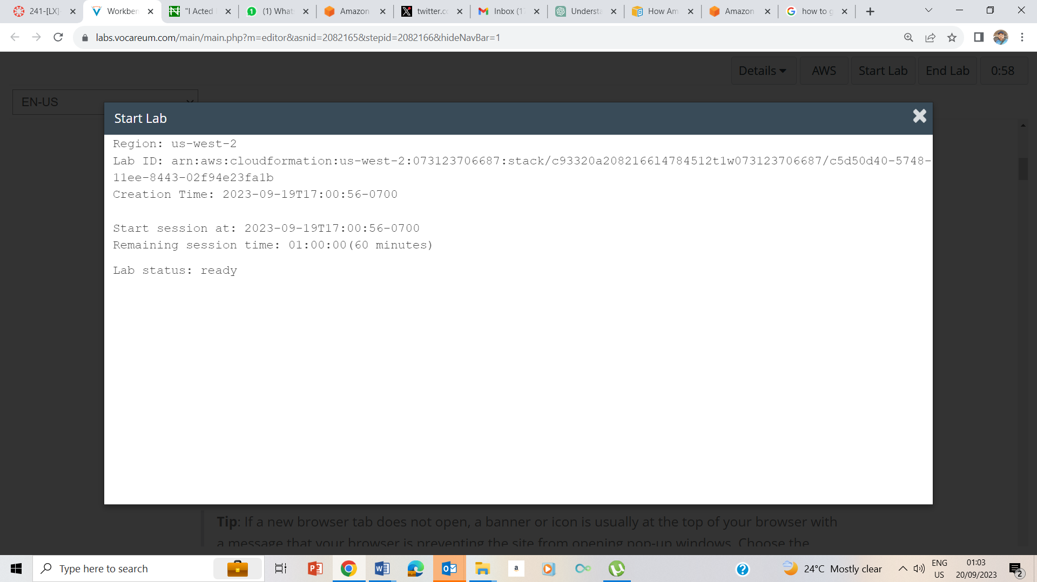

1-2 Starting the lab

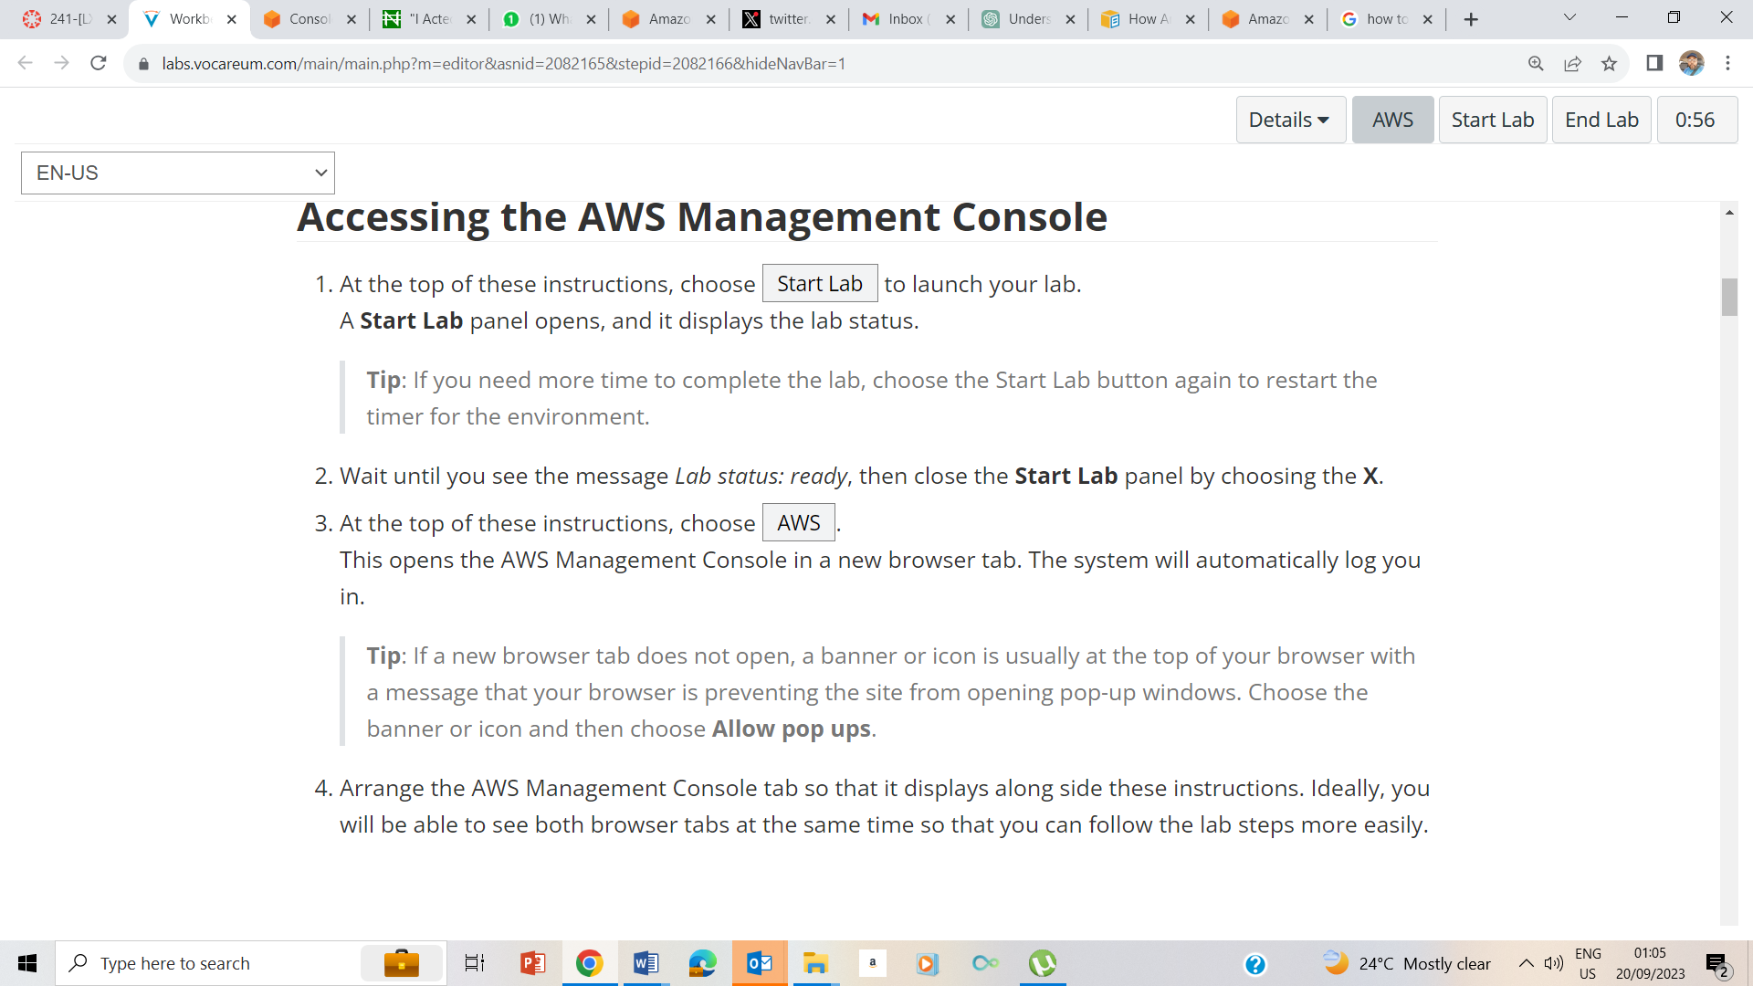

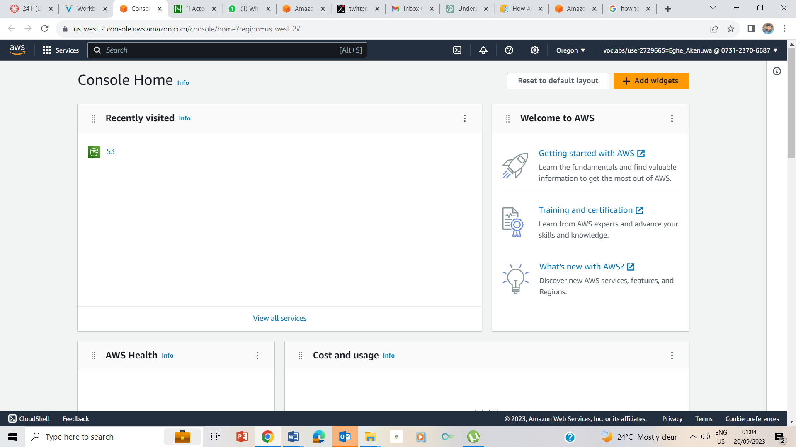

3-4. I clicked on AWS on the instruction page to take me to the AWS Management page

## Task 1: Use SSH to connect to an Amazon Linux EC2 instance

### Windows Users: Using SSH to Connect

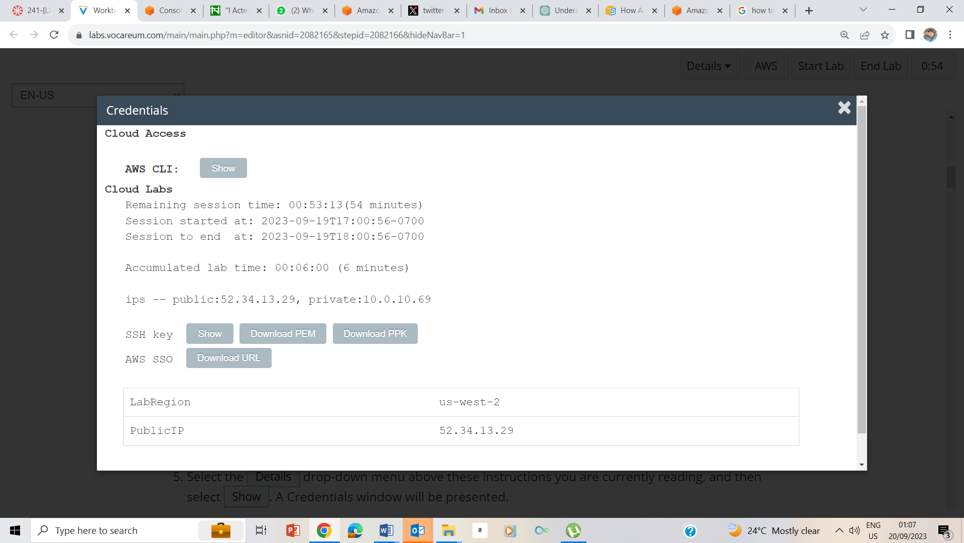5-8. I clicked on the Details drop down box at the top of the Instruction page, and selected show. It brought out the credentials page, when I now clicked on Download PPK, and also made a note of the public IP address which is 52.34.13.29

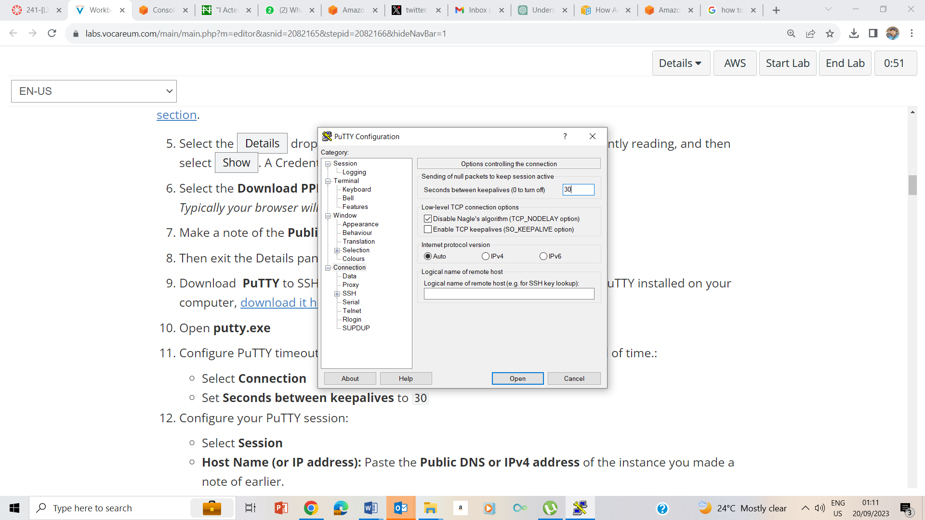

9-11 Opened Putty file, from my downloads, ran the putty.exe file, and on the putty page, I clicked on connection and set the seconds between keepalives to be 30.

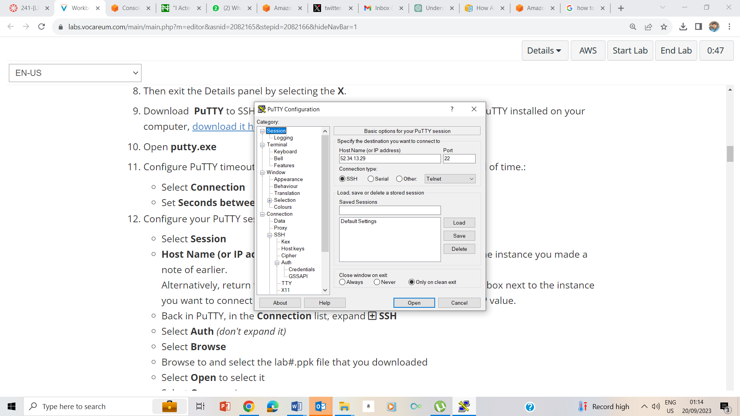

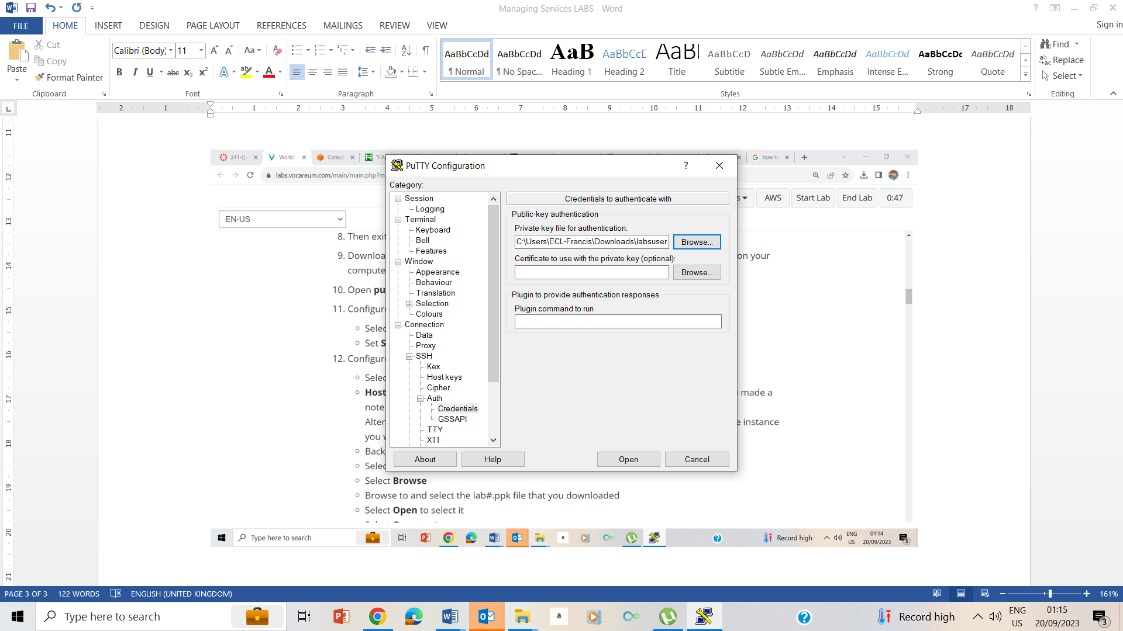

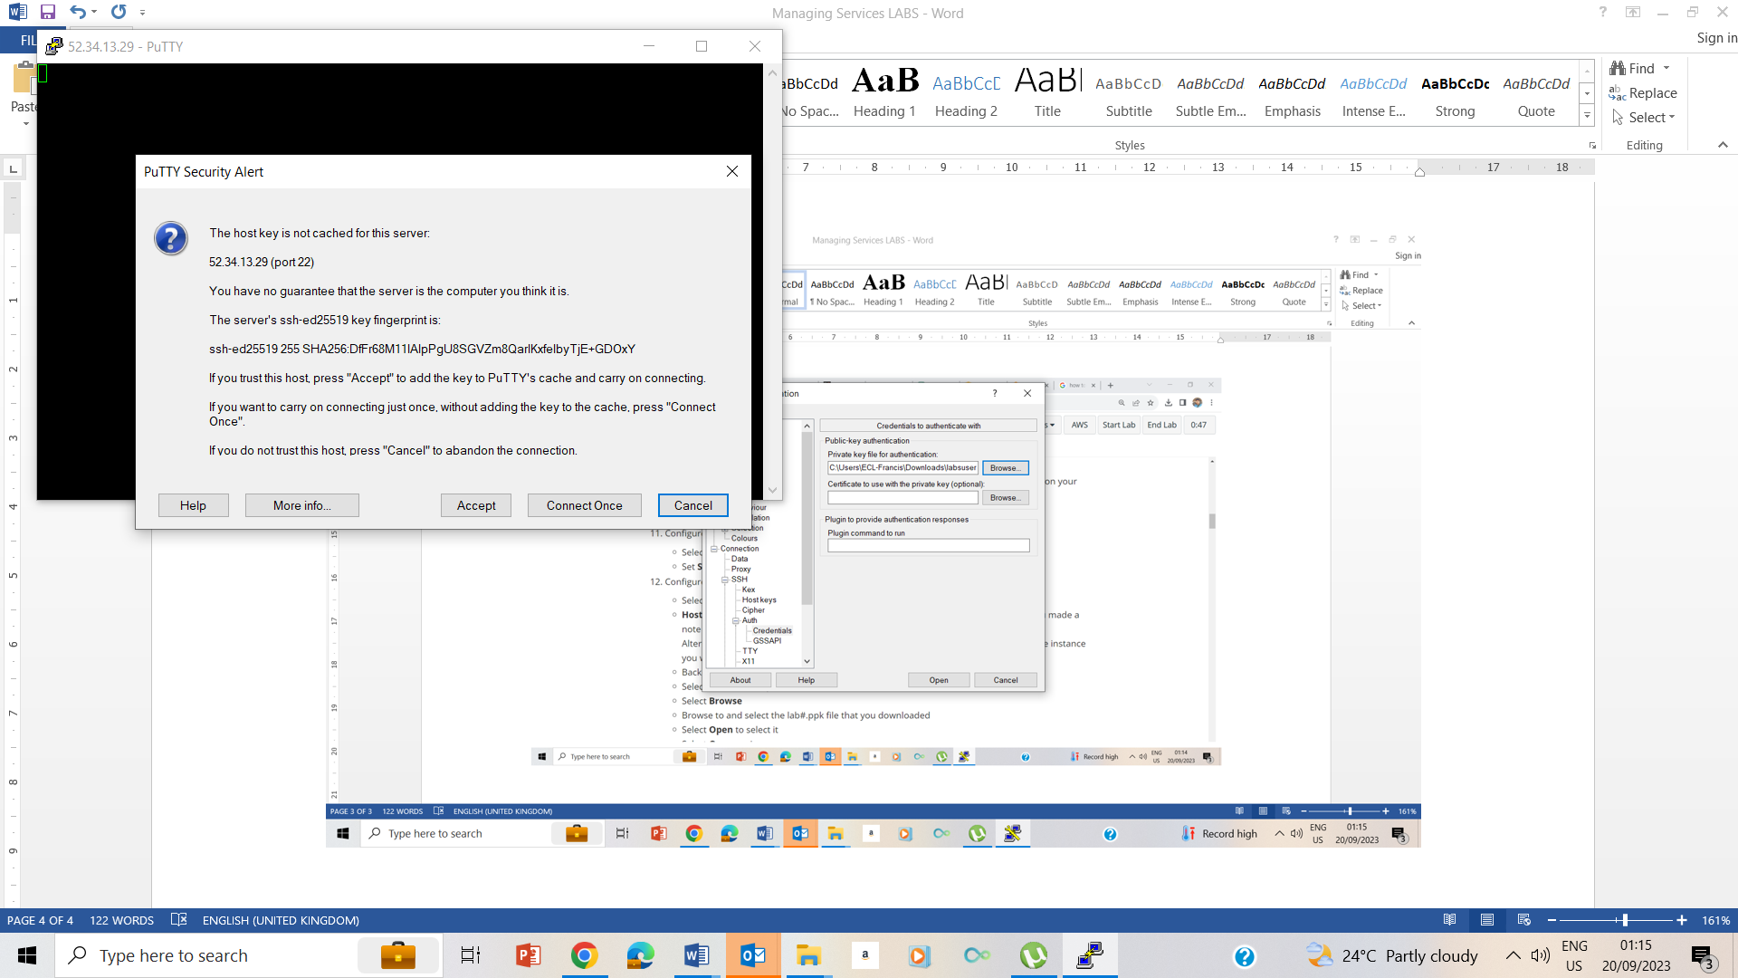

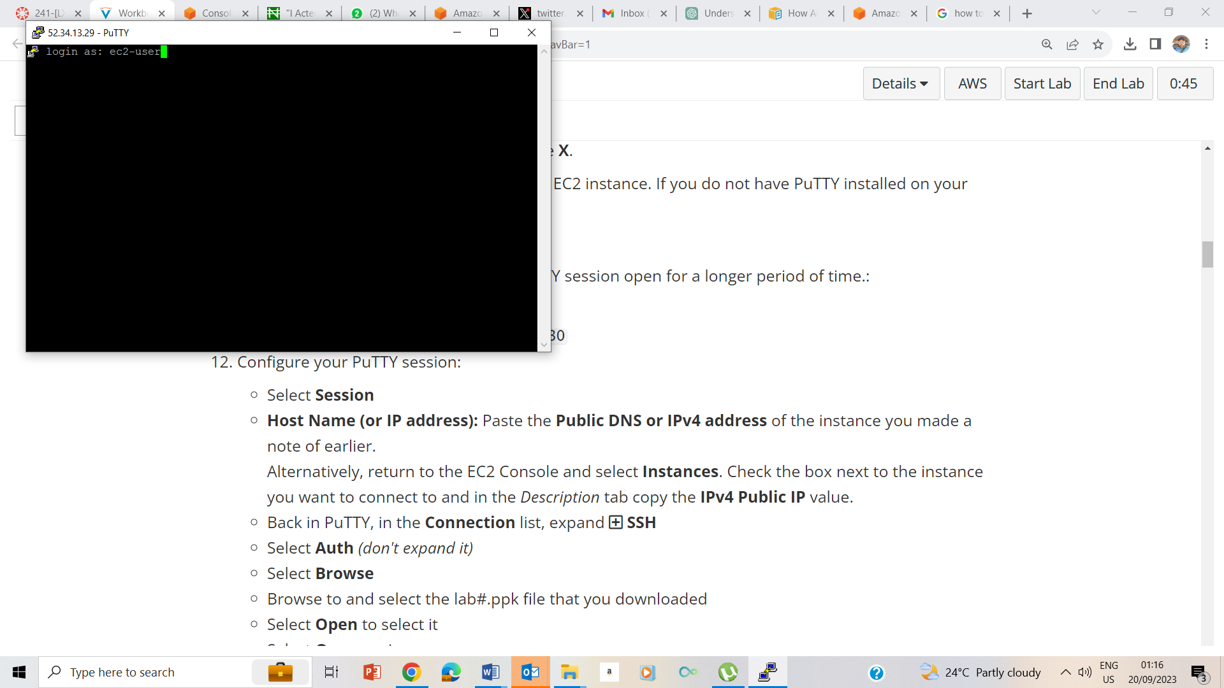

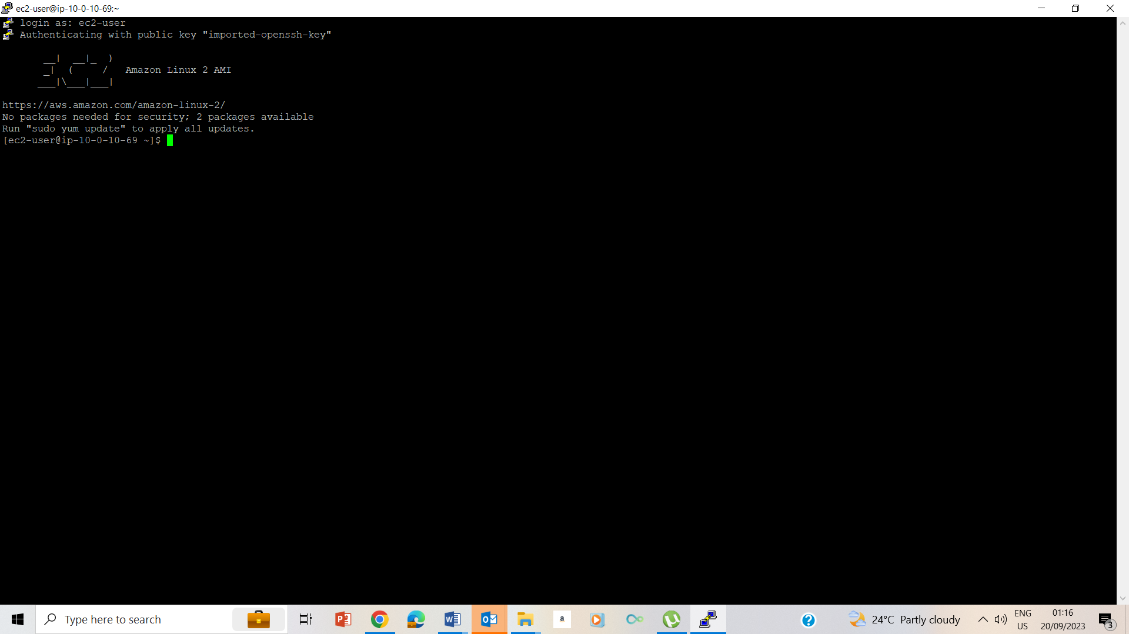

12-15 I configured my putty file.

## Task 2: Check the Status of the httpd Service

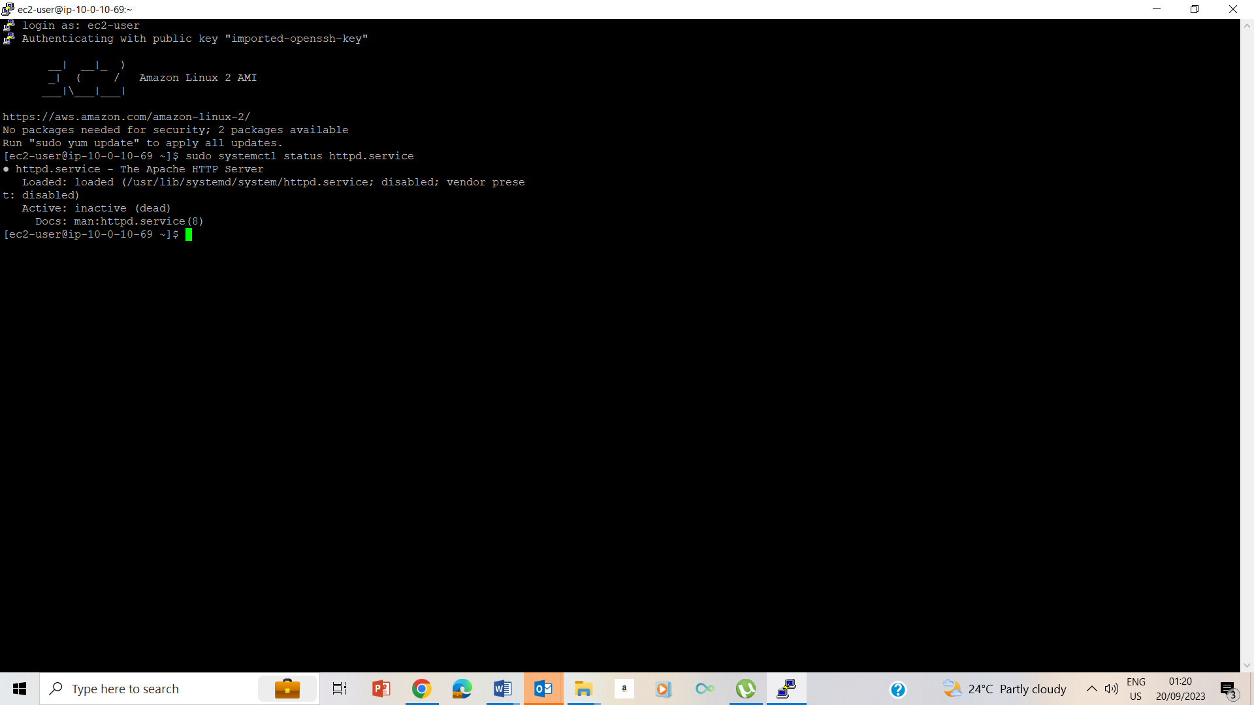

24. Checked the status of the system using systemctl command

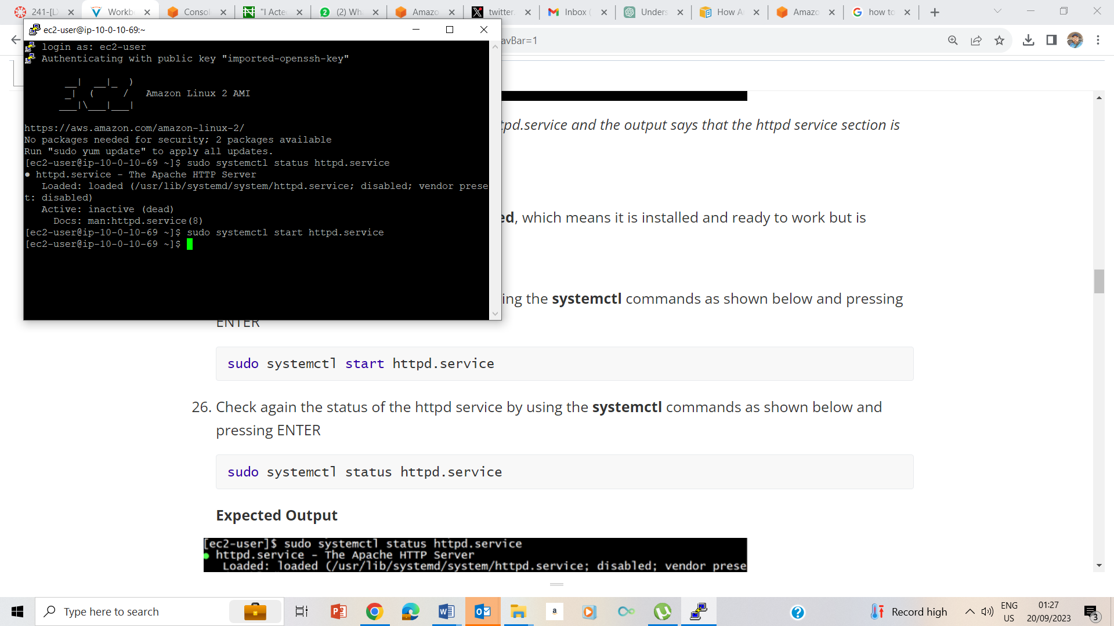

25, Starting the systemctl service using the start command

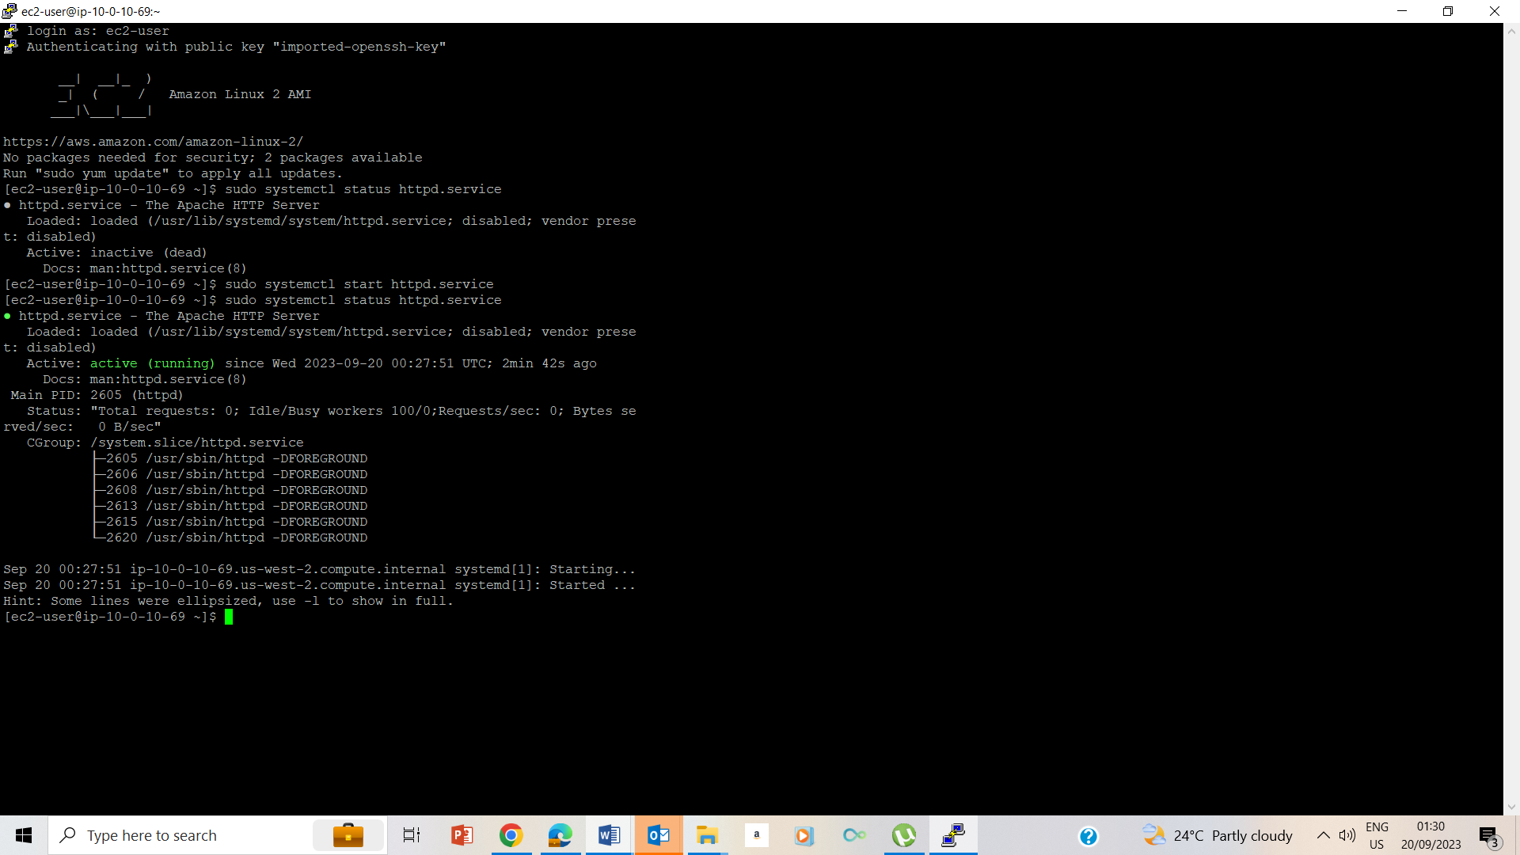

26. Checking the status of the system using the status command. i.e. sudo systemctl status httpd.service

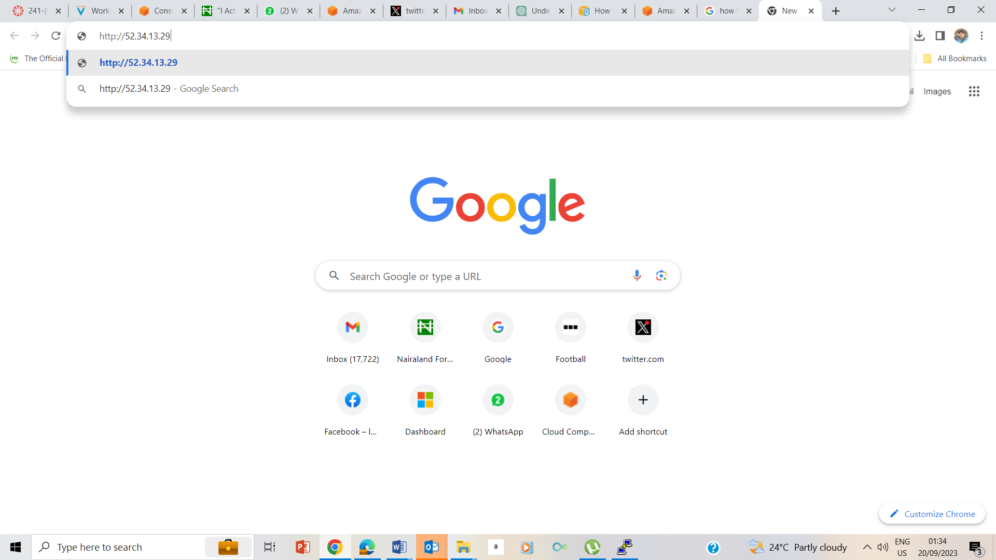

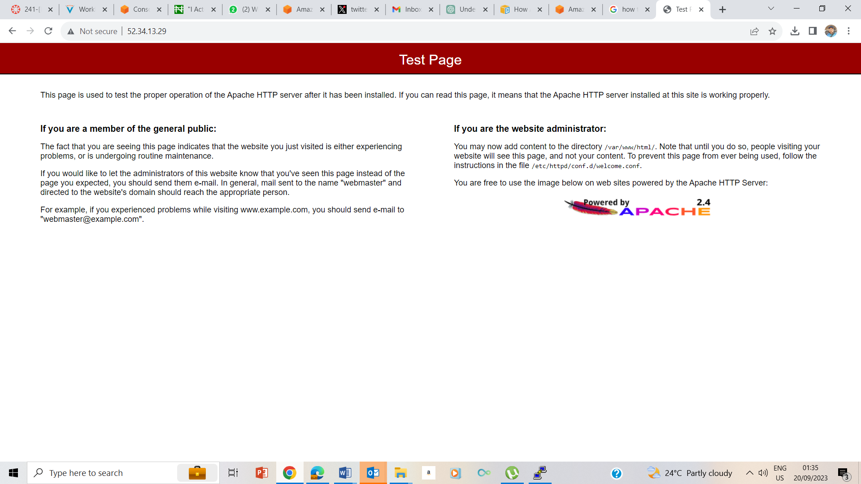

27. Tested the functionality of the httpd command ie working correctly by opening a new tab on my browser and running the public ip address that I noted earlier.

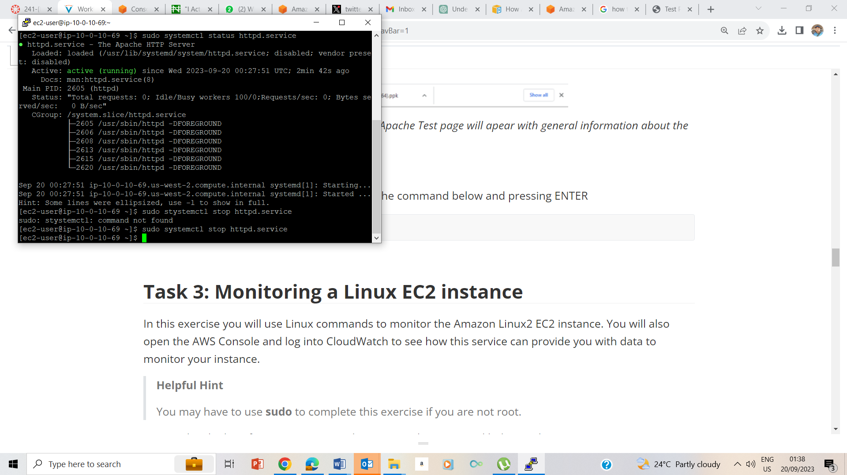

28. Stopped running the httpd service by using the stop command. Ie sudo sydtemctl stop httpd.service

## Task 3: Monitoring a Linux EC2 instance

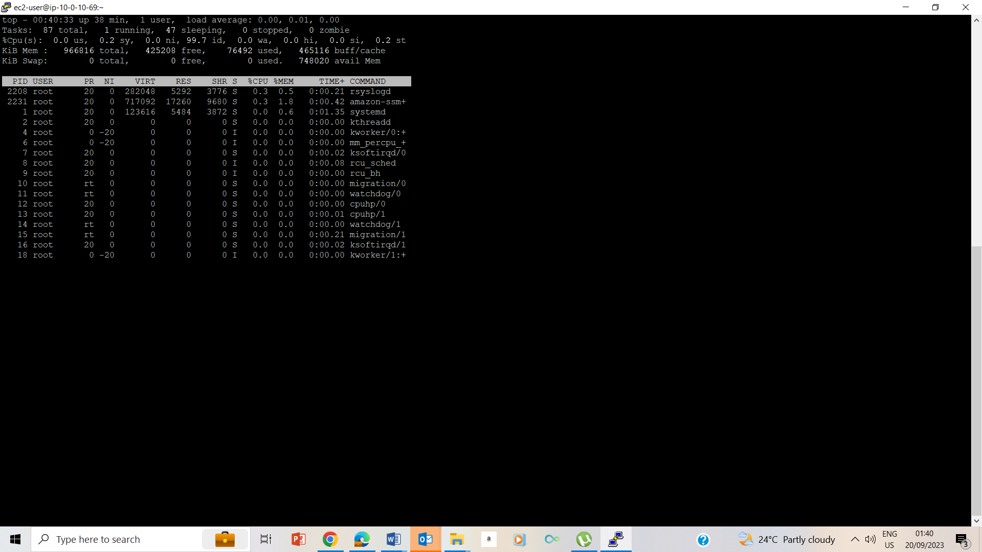

29. list the prosesses running using the top command. I later hit q to exit

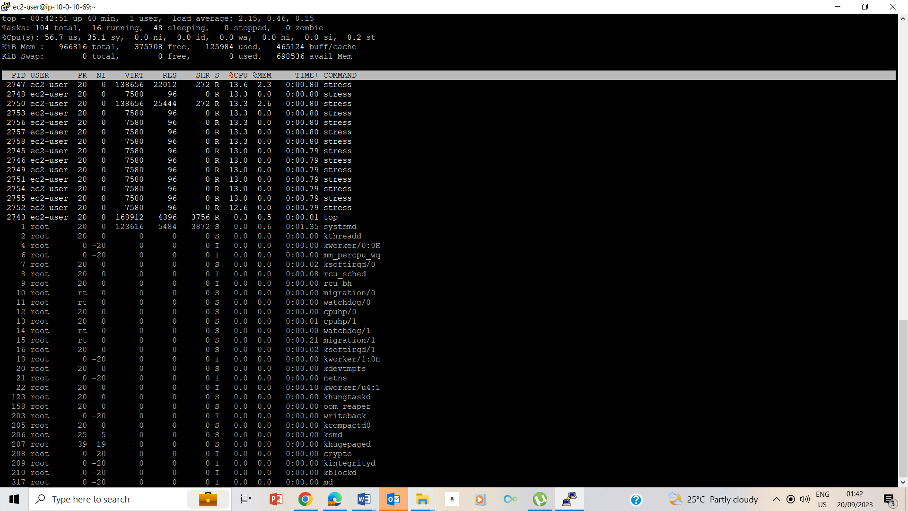

30. ran the ./stress.sh & top command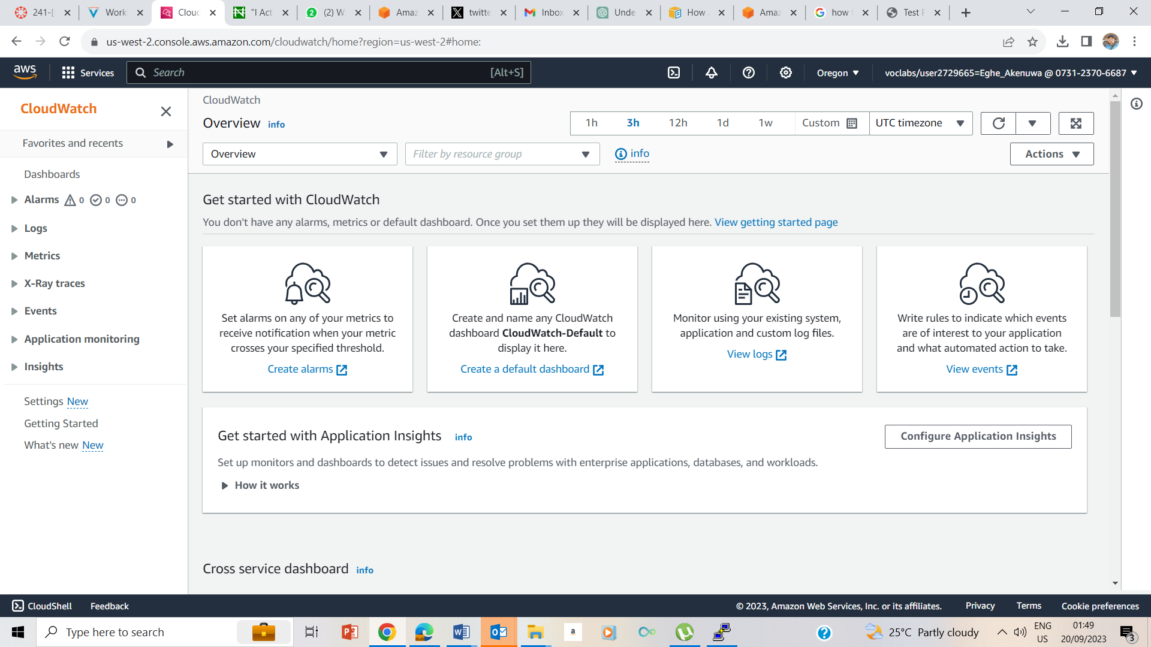

31-33 Clicked on the AWS console at the top of the instruction page to open a new AWS management console. I now searched for the CloudWatch to take me to CloudWatch page.

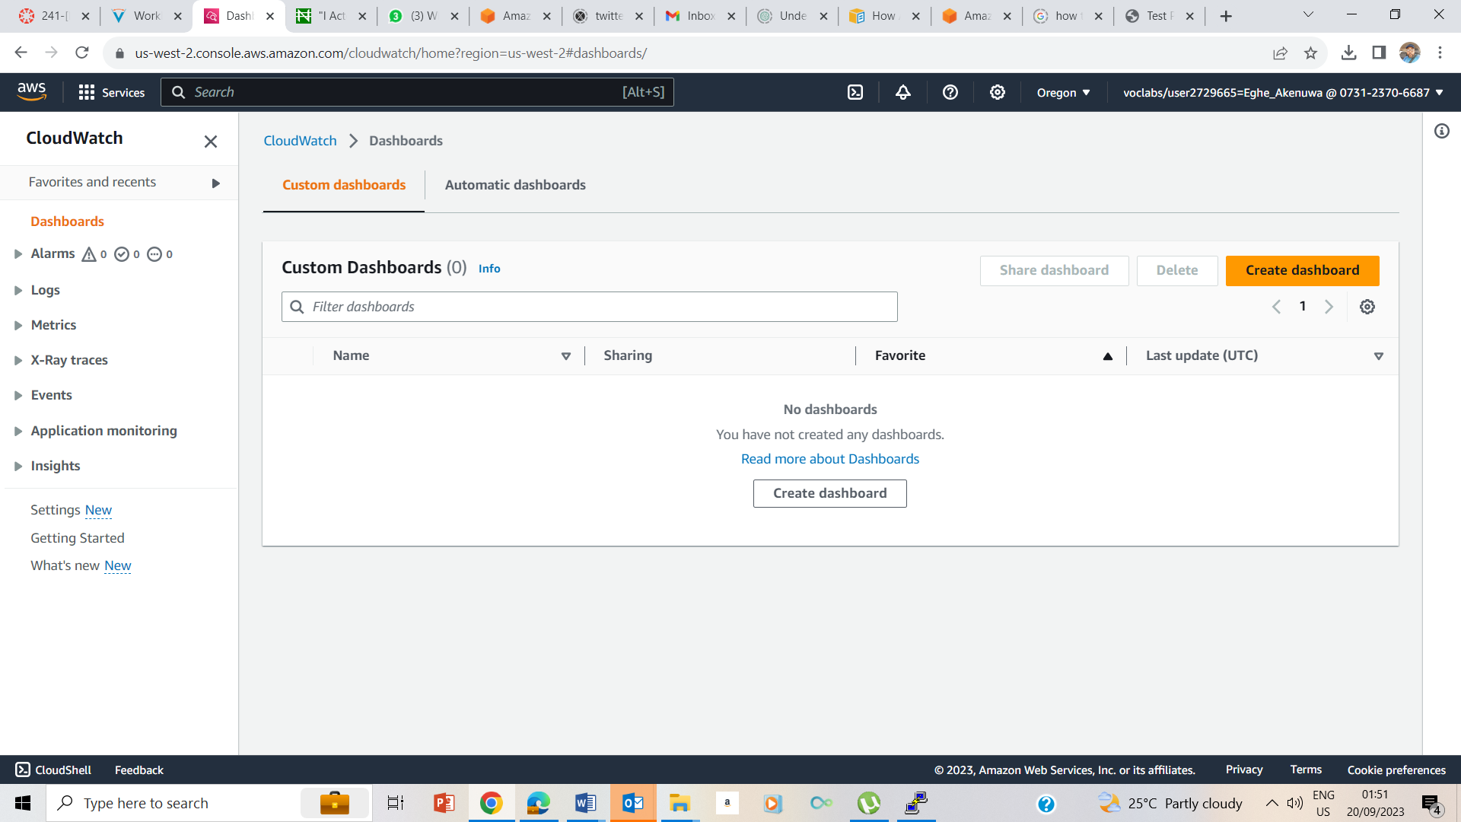

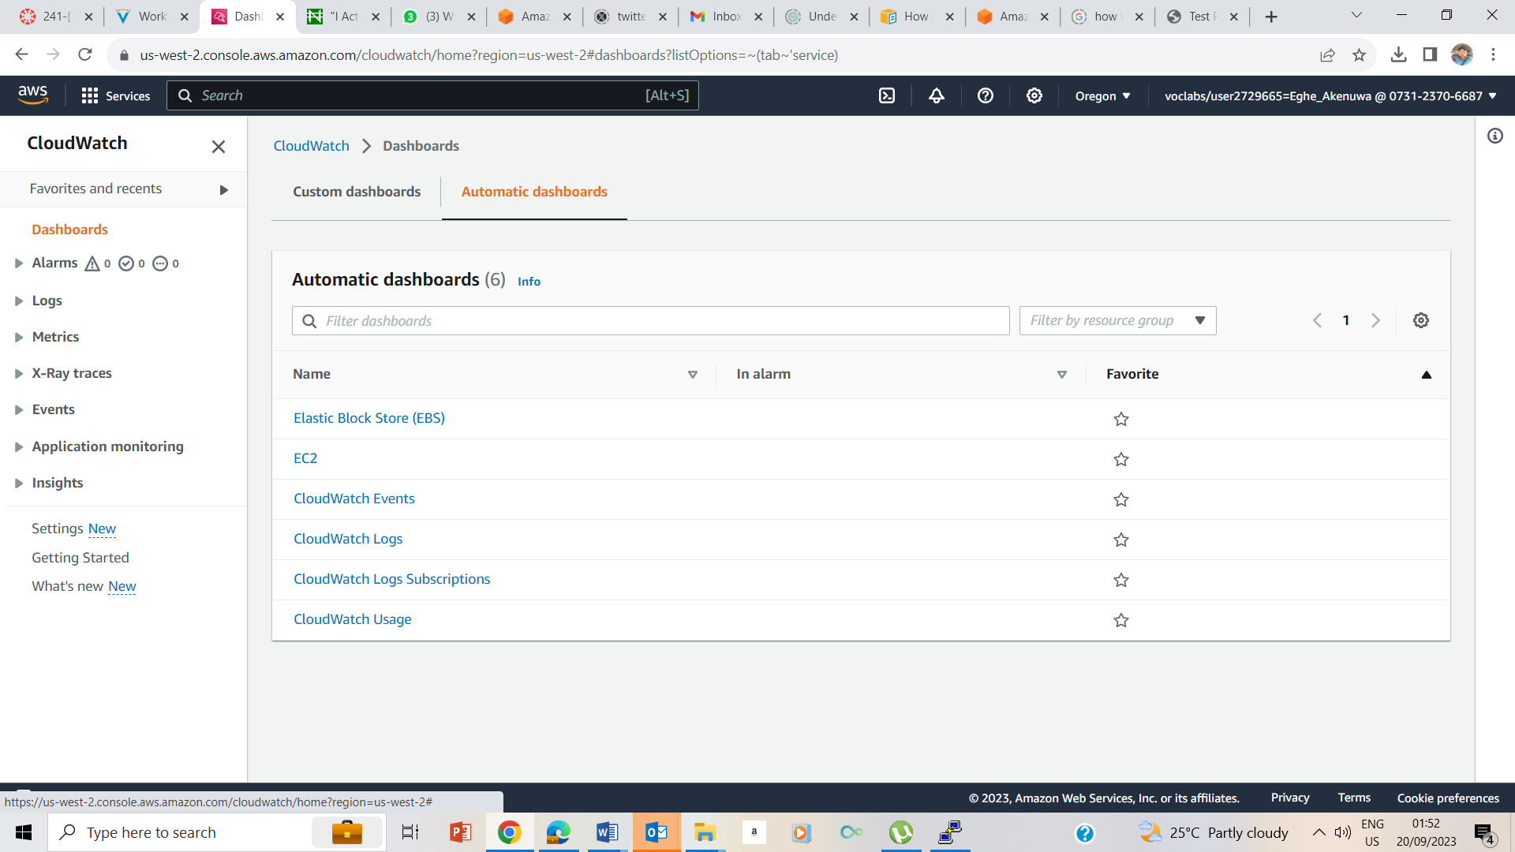

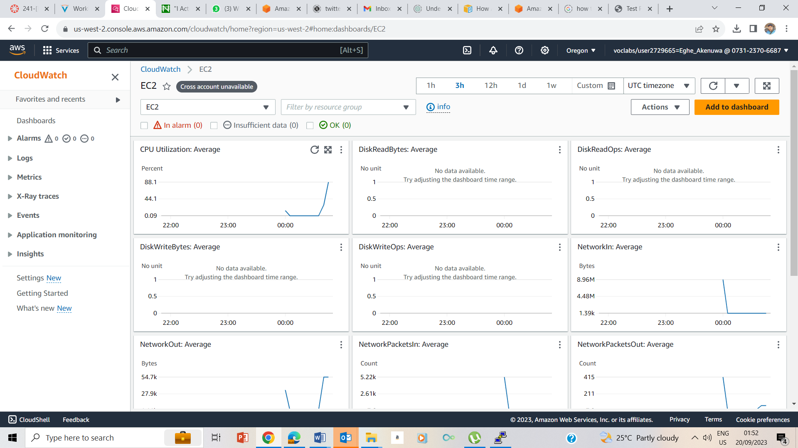

34. At the top of the CloudWatch page, I selected Dashboard, the Automatic Dashboard, and finally EC2

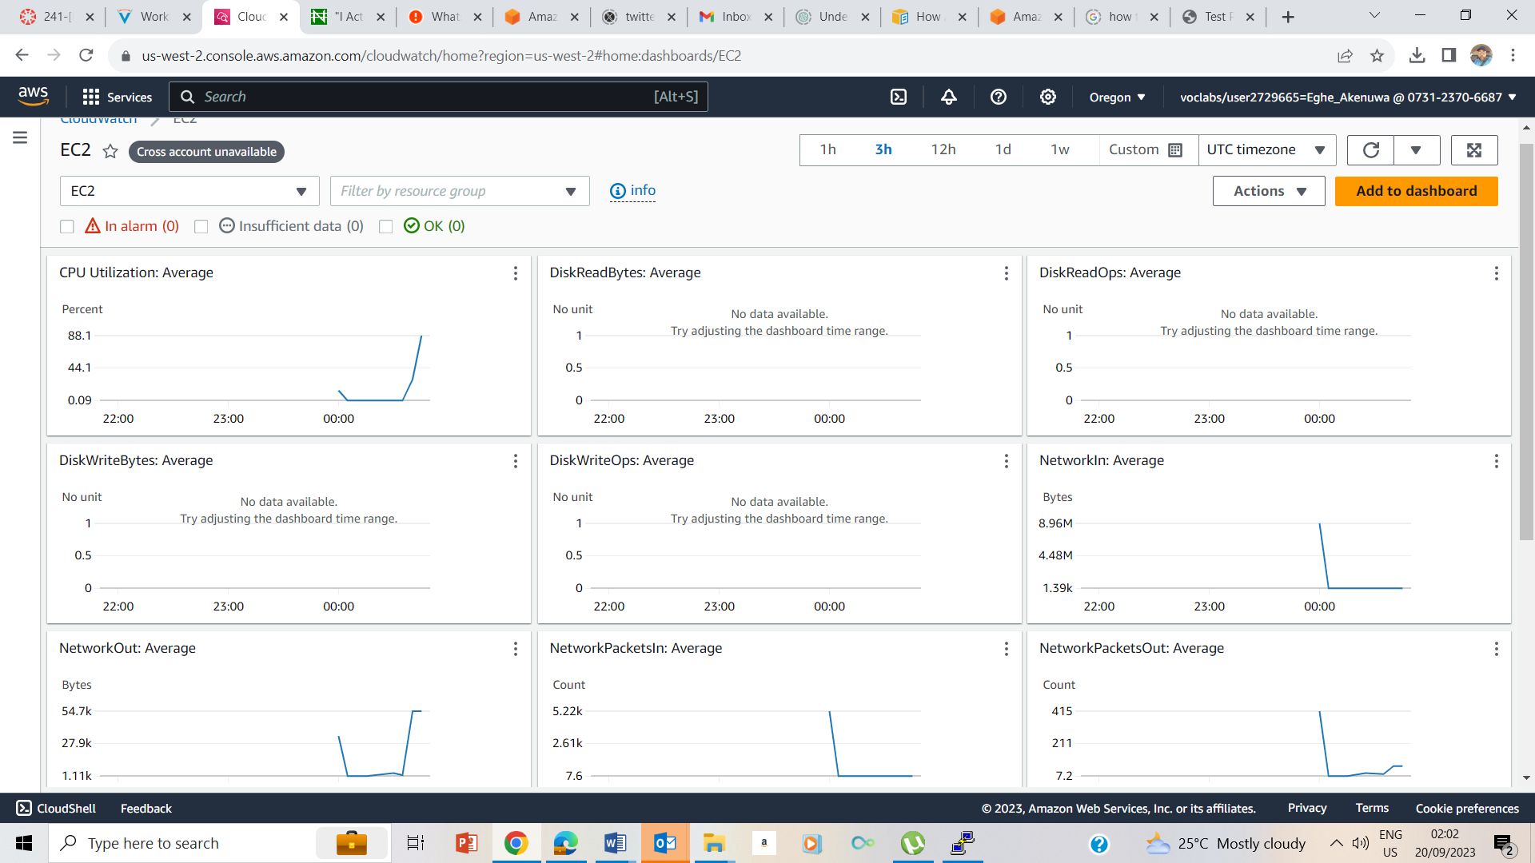

35 Average CPU Utilization page

## Lab Complete

